**CS551 First Increment Report**

**Project Title: FreakOut!**

*Sailaja Pedaprolu, 16157493*

*Srujana Kondamadugula, 16157492*

*Deepthi Sudha Muppalla, 16160854*

*Lakshmi Bhargavi Kadali, 16158203*

Report:

As a part of first increment, we have created the login and Registration pages. We used asp.net IDE in Microsoft Visual Studio. Whenever the user opens the application, login page is shown up and if the user is not an existing member, he can register by providing his basic details. We have provided privilege for admin to view the details of the registered and existing members. We also did provide a number of validator controls, if the given user credentials do not pass the validation, an error message is displayed. The screen shots of our application are as follows.

The login page of our application is

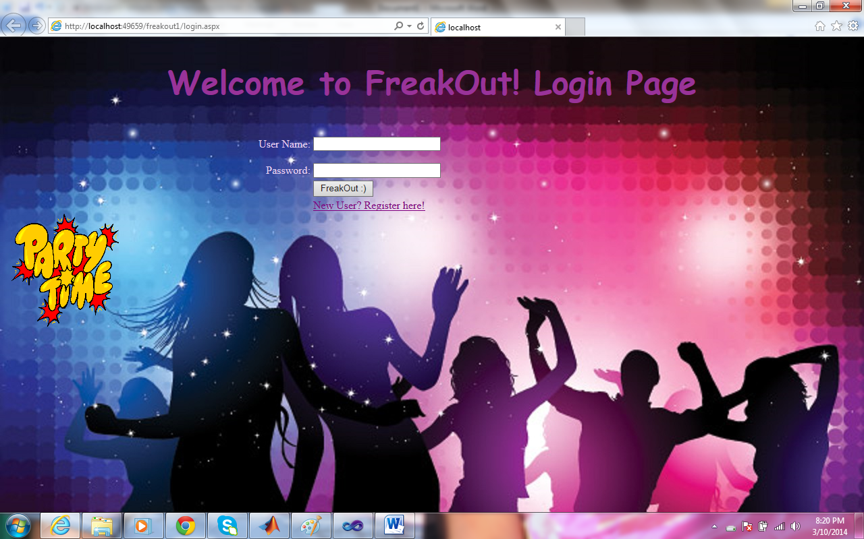

The closer view of our application..

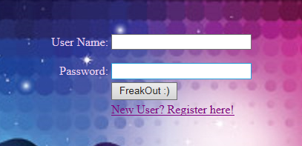

The user can use the application by providing his valid credentials, username and the password, if the user is new to the application, he has to register by clicking the “New user? Register here!” link. Once the link is clicked, the user is redirected to the registration page. Registration page takes the basic details of the user, the screen shot of the registration page is as follows,

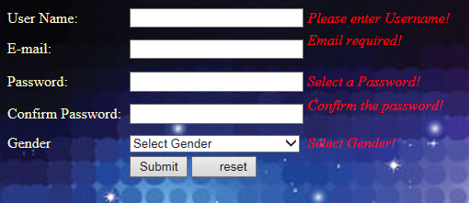

In the registration page, details like User Name, E-mail, Password, Confirm Password, and Gender have been included, we used required field validator for User Name, regular expression validator for the Email and compare field validator has been used for password and confirm password. A dropdown list has been used for the selection of gender.

We did test our application by trying to register new users, the screen shot for that is as follows,

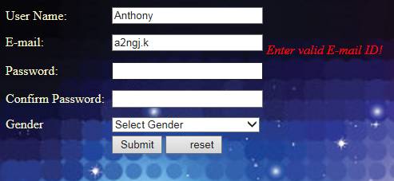

The user has not provided a correct Email, an error message saying “Enter valid E-mail ID” is displayed.

The user has now provided the correct Email ID.

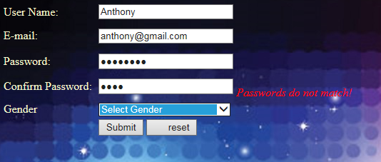

The user has now provided passwords which do not match, an error message saying “Passwords do not match!” is displayed. We did use the compare field validator in order to display the message whenever matched passwords are not provided.

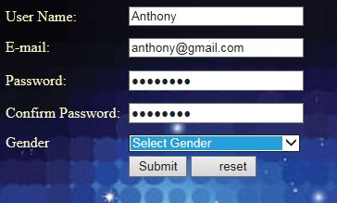

The user now selects the gender from the drop down list,

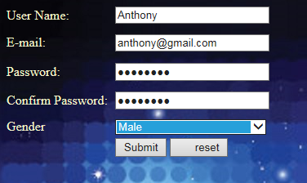

Thus when all the details are provided, the registration is complete.

When the admin logs in to the system, he has the privilege to view the details of the registered users, the screen shot is as follows,

Once the registration is complete, the user can now log in to the application by providing his user name and password.

The screen shot of the login page is



After the log in, the user is redirected to the next page,

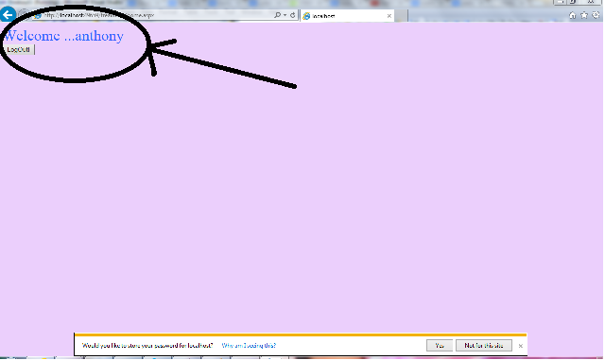

We are still working on the redirect page, as of now we have created logout to exit the application.

The admin has the privilege to view the details of the registered users whenever he logs in to the application. Whenever a new registration is done, a unique global id is created for every user.

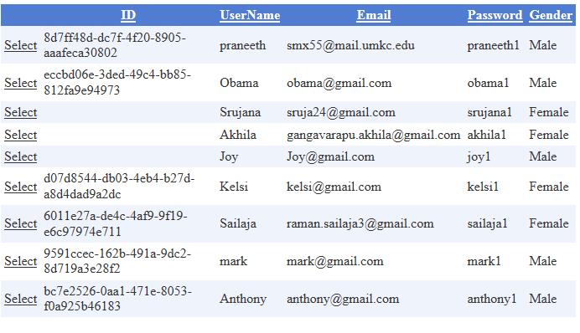

Note: we are planning to use twitter bootstrap for the front end design so that it is compatible with all the user GUI’s.

The scrum do link of our project is

<https://www.scrumdo.com/projects/project/ase-project3/summary>​

The URL of our website is

[http://kc-sce-cs551.kc.umkc.edu/aspnet_client/Group6/freakout1/login.aspx](http://www.facebook.com/l.php?u=http%3A%2F%2Fkc-sce-cs551.kc.umkc.edu%2Faspnet_client%2FGroup6%2Ffreakout1%2Flogin.aspx&h=zAQHRL3sO)